

**GRADE 10 ACADEMIC SYLLABUS**

*The grade 10 course of study revolves around genre study. Therefore, students in English 10 will focus on close reading strategies in various genres to understand what tools authors use to achieve their purposes and how different genres achieve the same purpose with a different toolbox. This course is about the characteristics of the different genres, the conventions of reading various genres and the differences between the genres****.***

**READING**

* As students learn to develop close reading skills, they will work to make distinctions amongst drama, fiction, poetry, and nonfiction. While literary elements will be reviewed and expanded, tone and theme statements will be highlighted. Additionally, students will be introduced to rhetorical analysis and reminded of literary analysis. To complement class work, students will also engage in independent reading.

**WRITING**

* The focus of writing in tenth grade is analysis of text. Students will synthesize their interpretations of a piece of reading in a literary analysis paper. Additionally, students will create pieces of writing that analyze professional writing samples and imitate the writing style of the studied genres in a genre apprentice piece. Students will use their knowledge of genre to guide decisions about topic, audience, and organizational structure.

**SPEAKING**

* Students will interact with a text, articulate a position, and actively engage in both formal and informal class discussion.

**OTHER ACTIVITIES**

* While students can expect to refine their mechanical skills and improve their vocabulary, the focus of the course remains centered on analysis of text. To help facilitate learning and monitor progress, activities such as projects, homework, quizzes, visual analysis, online discussion, or presentations may be implemented.

**GRADING**

* Central Bucks East has instituted a grading system that works to assess information and skills that students authentically have mastered while still acknowledging the importance of work habits. Therefore, students will be graded in different categories, including non-graded formative assessments that appear in Infinite Campus as a monitor of student progress. Summative assessments reflect students’ mastery of skills and constitute 90% of the marking period grade, while the other 10% is determined by students’ responsibility in work submission. All tenth graders will complete two core assignments—a literary analysis paper and a genre apprentice piece—each of which counts for 10% of the entire course grade. The final exam is also worth 10% of the entire course grade.

**GENERAL CLASS EXPECTATIONS/POLICIES**

**BASICS**

* I expect that students are familiar with the guidelines and rules set forth in the CB East Student Handbook. Please remember that respect is crucial; you will always have mine. Please extend the same courtesy to your classmates and to me.

**ATTENDANCE**

* Because I am serious about the work we do in class, I expect you to be as well. Therefore, it is important for you to make every effort to be in class every day. When you miss class repeatedly, your work will begin to suffer. If I see a pattern of frequent absence or lateness, I may call home. Check your email if absent.

**HOMEWORK and CLASSWORK**

* Due Dates: Turn in work when it is due. If absent, you must e-mail your paper to me. An excuse note/pass (in accordance with Central Bucks policy) must be submitted to the attendance office upon return to school.
* Missed homework/assignments: You may only make up homework/assignments if you were absent. For each day you are out, you have one day to submit that day’s missed homework. Make-up work is YOUR RESPONSIBILITY, not mine.
* Missed tests: Make every effort to take your tests on time. Talk to me about make ups; they will usually occur in the testing center.
* Extra credit: I do not offer extra credit projects, so work to the best of your ability every day.
* Supplies: Always bring your laptop. For class you will need your own highlighter, a package of post it flags (red, blue, yellow, green—see suggestions below), regular post its, and an 8-count box of crayons/colored pencils.

[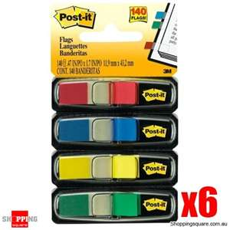](http://images.search.yahoo.com/images/view;_ylt=A0PDoTCgPVVOKicAABqJzbkF;_ylu=X3oDMTBlMTQ4cGxyBHNlYwNzcgRzbGsDaW1n?back=http://images.search.yahoo.com/search/images?p=post+it+flags&ei=UTF-8&fr=yfp-t-941&fr2=tab-web&b=1&tab=organic&w=475&h=475&imgurl=www.shoppingsquare.com.au/images/bundles/945.jpg&rurl=http://www.shoppingsquare.com.au/p_10491_3M_Postit_Mini_Colour_Flags_99mm_x_437mm_6_pack&size=107.4+KB&name=3M+Post-it+Mini+Colour+Flags+9.9mm+x+43.7mm+6+pack+(+Code:+BUNDLE+945+...&p=post+it+flags&oid=f2043fa9b82c4a5a0d5285228cf38d74&fr2=tab-web&fr=yfp-t-941&tt=3M+Post-it+Mini+Colour+Flags+9.9mm+x+43.7mm+6+pack+(+Code:+BUNDLE+945+...&b=0&ni=28&no=23&tab=organic&sigr=12o9meis9&sigb=13edmgnnv&sigi=11g4b2291&.crumb=DehYQRD4Vjr) [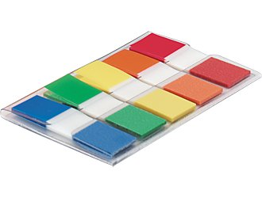](http://www.staples.com/office/supplies/moreviews?catalogId=10051&catentryId=17777&langId=-1&storeId=10001&imageClickSequence=0) [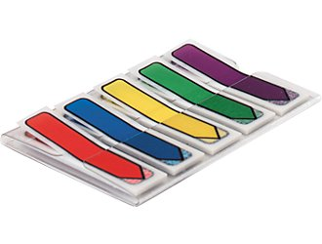](http://www.staples.com/office/supplies/moreviews?catalogId=10051&catentryId=19903&langId=-1&storeId=10001&imageClickSequence=0)

* School Wires: Visit my teacher site for resources and study materials: [http://www.cbsd.org//Domain/2076](http://www.cbsd.org/Domain/2076)

Note: I’m working to convert to Canvas as well.

* Academic Integrity: This is taken very seriously by the district and by me. Please consult the student handbook for additional information about plagiarism, cheating of any kind, and resulting consequences.

**KEYSTONE EXAMS**

* State testing includes both a fiction and nonfiction module and will be administered in December/May (during the semester you are scheduled for English class).

**Last, but not least...**

* Come prepared laptop, (notebook, pen, book).
* Work honestly and efficiently.
* Ask questions.
* Have a sense of humor.

I am looking forward to a great semester together. Best of luck in your first year of high school!

Sincerely,

Ms. Colleen Remar

cremar@cbsd.org

**CONTACT INFORMATION—Please print and return just this sheet**

**Parents/Guardians and Students**: After you have read and reviewed this material together, please sign below and return this portion to class. Your signatures indicate that you are now familiar with the basic focus of the course as well as expectations. If I need to contact you, I will look in Infinite Campus for your email or phone number. If at any time a question or concern arises, please feel free to contact me as well.

_________________________________ ____________________________________

Student name (print) Student Signature

_________________________________ ____________________________________

Parent/Guardian name (print) Parent/Guardian Signature

🡺 If there is anything that you think I should know about this student to help me be an effective teacher, please feel

free to share: